EFFECT OF EXERCISE AMONG COLLEGE STUDENT WITH PRIMARY DYSMENORRHEA

Ogbutor Udoji Godsday¹, Erumi Blessing Selly-U², Nofiu Oluwatobi Daniel³, Abdulfatah Hajara Aminu⁴, Ogene Chinelo Esther ¹, Ogbutor Emeke Godson¹, Isaac Precious¹, Anastacia Okwudili Ojimba⁵, Kosin Doris Ufoma¹

Author’s affiliation:
¹Faculty of Basic Medical Sciences, Delta State University Abraka, Delta State, Nigeria
²Faculty of Education, Delta State University Abraka, Delta State, Nigeria
⁴Faculty of Human Kinetics and Health Education, Ahmadu Bello University Zaria, Nigeria
⁵Department of Internal Medicine, Federal Medical Centre Asaba, Delta State, Nigeria

Declaration of conflict of interest:
The authors wish to declare that there are no potential conflicts of interest that could partially or fully prejudice the research report.
Correspondence Address
DR OGBUTOR Udoji Godsday: Faculty of Basic Medical Sciences, Delta State University Abraka, Delta State, Nigeria. Phone: +2348138474624. Email: udojiogbutor@delsu.edu.ng, gcclinics@yahoo.com

Abstract
Introduction: Primary dysmenorrhea is a prevalent menstrual disorder among college students, characterized by cyclic lower abdominal pain that significantly interferes with academic performance and quality of life. While analgesics remain the most commonly used treatment, increasing attention has been directed toward non-pharmacological approaches such as exercise. This study assessed the comparative effectiveness of exercise, analgesics, and a combination of both in reducing pain intensity among college students with primary dysmenorrhea. Methodology: A quasi-experimental study design was employed involving college students diagnosed with primary dysmenorrhea. Participants were assigned into three groups: combined exercise and analgesics (Group 1), exercise only (Group 2), and analgesics only (Group 3). Baseline pain intensity was measured using the Visual Analogue Scale (VAS). Following the intervention period, post-intervention pain scores were reassessed. Data were analyzed using paired t-tests and one-way analysis of variance (ANOVA) with post-hoc comparisons. Results: Baseline pain scores were comparable across groups, with mean pre-intervention VAS scores of 8.7 ± 1.3 in Group 1, 8.6 ± 1.4 in Group 2, and 8.8 ± 1.3 in Group 3 (p = 0.595). Post-intervention pain intensity significantly decreased in all groups. Group 1 showed the greatest reduction, with mean VAS decreasing from 8.7 ± 1.3 to 4.1 ± 0.9. Group 2 decreased from 8.6 ± 1.4 to 4.8 ± 1.2, while Group 3 decreased from 8.8 ± 1.3 to 5.7 ± 1.5. One-way ANOVA revealed a significant difference in post-intervention pain scores among the groups (F = 45.67, p < 0.001, η² = 0.24). Conclusion: The combination of exercise and analgesics produced the greatest pain reduction, followed by exercise alone, while analgesics alone were least effective. Exercise represents a safe, cost-effective, and clinically valuable intervention for managing primary dysmenorrhea among college students.
Keywords: Dysmenorrhea, analgesics, exercise, prevalent, students
INTRODUCTION
Dysmenorrhea is one of the leading causes for gynecological consultation with a global prevalence ranging from 15.8% to 91.5% in adolescent population [1]. According to the World Health Organization (WHO) in 2020, a prevalence report shows that 16.8% to 81% of women are suffering from dysmenorrhea. Dysmenorrhea is one the most frequent problems of women at child bearing age and affects 45 to 95% of them [3]. Dysmenorrhea can have negative effects on social relationships, academic work performance and psychological wellbeing. It is responsible for limitations in daily activities, sleep disturbances, difficulty in concentration, loss of self-confidence and social withdrawal; however, most adolescent and young women do not seek medical attention, resorting to self-medication with suboptimal management of these problems [4, 5].
Dysmenorrhea follows a clear cyclic pattern and is typically most severe during the first day of menstruation, often lasting up to 72 hours. Despite its high prevalence and its negative impact on daily activities, academic performance, and quality of life, dysmenorrhea remains inadequately treated and frequently disregarded. Many young females endure the pain silently without seeking medical attention due to cultural perceptions, embarrassment, and the belief that menstrual pain is a normal and inevitable part of womanhood that must be tolerated [6, 7, 8]. Dysmenorrhea is often viewed as a taboo subject, leading to delayed care-seeking behavior and underreporting, particularly among adolescents and young adults [9]. Consequently, healthcare professionals play a crucial role in identifying dysmenorrhea, educating affected females, providing reassurance, and recommending appropriate non-pharmacological interventions such as exercise to optimize treatment outcomes [10].
Primary dysmenorrhea is spasmodic in nature and is typically experienced as cramp-like pain in the lower abdomen, which may radiate to the lower back and thighs. The pain ranges from mild to severe and usually occurs just before or during menstruation [11]. This condition is frequently accompanied by systemic symptoms such as sweating, nausea, vomiting, headache, fatigue, abdominal bloating, backache, dizziness, diarrhea, and tremulousness, which further exacerbate functional impairment [12, 13]. The onset of primary dysmenorrhea typically occurs 6–12 months after menarche, coinciding with the establishment of regular ovulatory cycles [14].
The pathophysiology of primary dysmenorrhea is closely linked to hormonal changes during the menstrual cycle. In ovulatory cycles, rising progesterone levels following ovulation stimulate increased production of prostaglandin F₂α in the endometrium, leading to heightened uterine tone, intense myometrial contractions, reduced uterine blood flow, and ischemic pain [15, 16]. Elevated levels of leukotrienes and vasopressin also contribute to uterine hypercontractility and pain perception [11]. Psychological factors such as stress and anxiety further amplify pain sensitivity and are strongly associated with the severity of dysmenorrhea [17]. Primary dysmenorrhea occurs in the absence of identifiable pelvic pathology and often improves with increasing age, particularly following childbirth, although it may persist for several years in some individuals [18,19].
The main goal of dysmenorrhea treatment is to reduce pain and improve the functionality of patients, with nonsteroidal anti-inflammatory drugs and hormone therapy being most common [20, 21]. Note that these treatments are effective for many women, but approximately 25% continue to have pain. In addition, they noted that cultural differences also affect the use of analgesics and the oral contraceptive pill, with Chinese women ingesting significantly less than Australian women. Most women manage their symptoms with over-the-counter analgesics (ibuprofen, acetaminophen) and self-care (rest and heat application), rather than seeking medical advice. This is largely due to the perceived lack of effectiveness of these medications or the rejection of their use due to side effects [21] indicate that there are non-pharmacological self-care techniques, either physical or psychological, that can be practiced by women themselves such as, for example, physical exercise.
It has been observed that physical activity reduces stress, has antinociceptive properties and reduces levels of the prostaglandin subtype most closely related to PD [22, 23]. These same authors comment that it has been an activity recommended by physicians for this health problem since the 1930s and can currently be contemplated in the recommendations to patients provided ACOG. Furthermore, [24] specify that the use of physical exercise as therapy not only improves pain symptoms and mental health, but also quality of life. At the same time they emphasize that it is a low-cost option with no side effects [25].
METHODOLOGY
Research methodology is employed to investigate the effect of exercise on primary dysmenorrhea among college students. It details the research design, population and sampling methods, data collection instruments, data collection procedures, data analysis techniques, inclusive and exclusive criteria, ethical considerations, and limitations of the study.
Research Design
A quantitative research approach was adopted, utilizing a quasi-experimental design. This design allows for the examination of cause-and-effect relationships between exercise interventions and the severity of primary dysmenorrhea symptoms. Participants were divided into an experimental group, which received the exercise intervention, and a control group, which did not.
Quasi experiment one group pretest posttest design.
Setting: The study was conducted in Abraka, Delta state university, Delta state.
Duration of study: 2 Month at 95% confidence level.
Data collection duration: Training duration-3 days per week, one times in a day. Total study duration- 8 weeks.
Study Area
The study was conducted among female college students attending selected tertiary institutions. These institutions provide a diverse population of young women from different academic disciplines, making them suitable for assessing the effect of exercise on primary dysmenorrhea. The study environment included lecture halls, hostels and designated exercise areas within the campuses.
Population and Sampling
The target population comprised female college students aged 18 to 25 who experience primary dysmenorrhea. A purposive sampling technique was employed to select participation.
Inclusive Criteria
- Female who are having regular menses.
- Female within the age group 18-25years.
- Female who are willing to participate.
- Female must show symptoms of pain before or during menses.
Exclusion Criteria
- Female who are regularly practicing yoga and exercise
- Female diagnosed with PCOD and on treatment.
- Female with secondary Dysmenorrhea (fibroid, cervical stenosis)
- Female who do not feel pain during menses.
- Female with irregular menstrual cycle.
- Female with cardiovascular health conditions.
Sample Size
Pain reduction was calculated by subtracting the post intervention VAS score from the pre intervention VAS score for each group.
Formula used
Mean Pain Reduction equals Pre VAS minus Post VAS
$$n_{0} = \frac{Z^{2} p ×q}{d^{2}}$$
Where
Z: is the standard normal deviation at ninety five percent confidence level which is one point nine six
P: is the estimated prevalence of primary dysmenorrhea among college students
q: is one minus p
d: is the margin of error
Group 1 Analgesic plus Exercise
Pre intervention mean VAS equals 8.7
Post intervention mean VAS equals 4.1
Mean pain reduction: 8.7 minus 4.1 equals 4.6
This indicates a very large reduction in menstrual pain following combined analgesic and exercise intervention.
Group 2 Exercise Only
Pre intervention mean VAS equals 8.6
Post intervention mean VAS equals 4.8
Mean pain reduction: 8.6 minus 4.8 equals 3.8
This shows a substantial reduction in pain due to exercise alone.
Group 3 Analgesic Only
Pre intervention mean VAS equals 8.8
Post intervention mean VAS equals 5.7
Mean pain reduction: 8.8 minus 5.7 equals 3.1
This reflects pain reduction due to analgesic use only, but less than the other two groups.
PERCENTAGE PAIN REDUCTION CALCULATION
Formula: Percentage reduction equals
Mean pain reduction divided by Pre VAS multiplied by 100
Group 1: 4.6 divided by 8.7 multiplied by 100 equals 52.9 percent
Group 2: 3.8 divided by 8.6 multiplied by 100 equals 44.2 percent
Group 3: 3.1 divided by 8.8 multiplied by 100 equals 35.2 percent
Sampling Technique
A multistage sampling technique was employed.
First, eligible colleges were selected using purposive sampling.
Second, participants who met the inclusion criteria were selected using simple random sampling and then randomly assigned into the three study groups to minimize selection bias.
Research Instrument
Data were collected using a structured and self administered questionnaire consisting of the following sections
- Sociodemographic characteristics
- Menstrual history and dysmenorrhea characteristics
- Exercise participation pattern
Pain intensity was measured using the Visual Analogue Scale VAS, ranging from 0 indicating no pain to 10 indicating severe pain. Anthropometric measurements such as height and weight were taken using standardized measuring instruments.
Validity of the Instrument
Content and face validity of the questionnaire were established through review by experts in nursing, physiotherapy and reproductive health. Their corrections and suggestions were incorporated to ensure that the instrument adequately measured variables related to dysmenorrhea and exercise intervention.
Reliability of the Instrument
Reliability was determined using a test retest method during a pilot study conducted among a similar population not included in the main study. The reliability coefficient obtained was satisfactory, indicating consistency and stability of the instrument over time. In this study standardized tools are used i.e VAS (Visual Analogue scale) Reliability is high. ICC (0.99): (95%.Cl 0.989 to 0.992)
Ethical Consideration
This study was approved by the institution's ethical committee from the university. The study explained to all the participants and informed consent was taken from each participant before data collection with ethical number: RCB/FBMC/DELSU/25/757
Data Collection Tool
Face to face interview: A Socio Demographic profile of girls who are having primary dysmenorrhea was done to gather information on current age, weight, height, Age of Menarche, length of Menstrual cycle, Number of sanitary pad used per day, onset of Menstrual pain, Drug history from there medical history at the Clinical Health Center at Abraka.
Visual Analog Scale (VAS): To assess the intensity of menstrual pain, with scores ranging from 0 (no pain) to 10 (worst possible pain). Visual Analogue pain scale was used to assessed pain for pre and post intervention of the 3 groups ( two experimental and one control group)
Menstrual Symptom Questionnaire (MSQ): Evaluated the frequency and severity of dysmenorrhea symptoms and their impact on daily activities
Data Collection Method
The study was conducted over two menstrual cycle
Baseline Assessment: Participants completed the VAS and MSQ during their first menstrual cycle to establish baseline data.
Pre- Intervention Period: The experimental group engaged in a structured exercise program consisting of aerobic and stretching exercises, performed three times per week for 30 minutes each session, over the next menstrual cycle. The control group maintained their usual activities without any exercise intervention.
Post-Intervention Assessment: At the end of the each menstrual cycle, both groups completed the VAS and MSQ to evaluate changes in pain intensity and symptom severity.
Plan of Data Analysis
Data were analyzed using descriptive and inferential statistics:
Descriptive Statistics: Calculated means and standard deviations for demographic variables and baseline measurements.
Inferential Statistics: Performed independent t-tests to compare changes in VAS and MSQ scores between the experimental and control groups, with a significance level set at p < 0.05.
Limitations of the Study
Potential limitations include:
Self-Reporting Bias: Reliance on self-reported data may introduce bias.
Sample Size: The relatively small sample size may limit the generalizability of the findings.
Compliance: Variations in participants' adherence to the exercise regimen could affect the results.
RESULT
This chapter presents the analysis and interpretation of data collected to assess the effect of exercise among college students with primary dysmenorrhea among participants. The primary objective of this chapter is to evaluate the changes in key physiological variables; Analgesic and exercise, exercise, and Analgesic and no exercise measured at different time intervals before, and after the physical exertion. The analysis is designed to determine the statistical significance of observed variations using both descriptive and inferential statistical methods, including the paired sample t-test and one-way analysis of variance (ANOVA). The interpretations provided are aimed at explaining the physiological relevance of these changes in the context of exercise among college student with primary dysmenorrhea. All statistical analyses were performed at a 95% confidence level (p < 0.05), and results are interpreted accordingly.

Table 1: Demographic Characteristics using Descriptive Statistics to interpret the Effect of Exercise among College Student with Primary Dysmenorrhea
Variable | Category | Group 1 Analgesic plus Exercise n equals 100 | Group 2 Exercise Only n equals 100 | Group 3 Analgesic Only n equals 100 | Total Frequency n equals 300 | Percentage
Age of Menarche (Years) | 9 to 10 | 20 | 20 | 20 | 60 | 20.0
 | 11 to 12 | 52 | 50 | 51 | 153 | 51.0
 | 13 to 14 | 28 | 30 | 29 | 87 | 29.0
Height (m) | Below 1.50 | 16 | 17 | 16 | 49 | 16.3
 | 1.50 to 1.60 | 65 | 62 | 64 | 191 | 63.7
 | Above 1.60 | 19 | 21 | 20 | 60 | 20.0
Current Age (Years) | 18 to 20 | 55 | 60 | 58 | 173 | 57.7
 | 21 to 23 | 33 | 30 | 34 | 97 | 32.3
 | 24 to 25 | 12 | 10 | 10 | 30 | 10.0
Weight (kg) | Below 50 | 14 | 13 | 14 | 41 | 13.7
 | 50 to 65 | 70 | 68 | 69 | 207 | 69.0
 | Above 65 | 16 | 19 | 17 | 52 | 17.3
Statistical Interpretation: The distribution of demographic variables across the three study groups shows a high level of similarity, indicating that the groups were comparable at baseline. Most respondents attained menarche between 11 and 12 years, accounting for 51.0 percent of the total sample, with nearly equal frequencies across all groups. Height distribution was also comparable, as the majority of participants fell within the 1.50 to 1.60 m category, representing 63.7 percent of the respondents. In terms of current age, over half of the participants were aged 18 to 20 years, while about one third were within the 21 to 23 year range, with minimal variation across groups. Similarly, body weight was predominantly within the 50 to 65 kg category, comprising 69.0 percent of the sample, and was evenly distributed among the three groups. Overall, the close similarity in age of menarche, height, current age, and weight suggests homogeneity of the study groups. This indicates that these demographic characteristics are unlikely to confound the assessment of the effect of exercise on primary dysmenorrhea, thereby strengthening the validity of comparisons made between the intervention groups.

Table 2: Demographic Characteristics using Descriptive Statistics to interpret the Effect of Exercise among College Student with Primary Dysmenorrhea
Variable | Category | Group 1 Analgesic plus Exercise n equals 100 | Group 2 Exercise Only n equals 100 | Group 3 Analgesic Only n equals 100 | Total Frequency n equals 300 | Percentage
Menstrual Cycle Length (Days) | 3 to 4 | 60 | 58 | 59 | 177 | 59.0
 | 5 to 6 | 40 | 42 | 41 | 123 | 41.0
Duration of Menstrual Pain (Days) | 1 to 2 | 67 | 66 | 67 | 200 | 66.7
 | 3 to 4 | 33 | 34 | 33 | 100 | 33.3
Drug History | NSAIDs | 30 | 0 | 35 | 65 | 21.7
 | Paracetamol | 15 | 0 | 15 | 30 | 10.0
 | Other Drugs | 10 | 0 | 10 | 20 | 6.7
 | No Drug History | 45 | 100 | 40 | 185 | 61.6
Sanitary Pads Used per Day | 10 or less | 63 | 61 | 63 | 187 | 62.3
 | More than 10 | 37 | 39 | 37 | 113 | 37.7
Statistical Interpretation: The menstrual cycle length and duration of menstrual pain were similar across all groups, with most participants reporting 3–4 day cycles (59.0%) and 1–2 days of pain (66.7%), indicating baseline homogeneity in menstrual characteristics. Drug history varied by group, with Group 2 (Exercise only) having no prior drug use, while Groups 1 and 3 had participants with NSAIDs, paracetamol, or other drugs, reflecting differences in prior pharmacological exposure. Sanitary pad usage was consistent across groups, with most participants using 10 or fewer pads per day (62.3%), suggesting uniform menstrual flow and minimizing its potential influence on pain assessment. Overall, the groups were largely comparable in menstrual characteristics, except for drug history, which aligns with the study design and allows assessment of exercise effects independently.
Descriptive Statistics (Mean and SD)
This section provides the mean, standard deviation (SD), and range for each variable across the three groups (Group 1: Analgesic + Exercise; Group 2: Exercise Only; Group 3: Analgesic Only):
Table 3: Descriptive Statistics (Mean ± SD) (n = 100)
Variable | Group 1 | Group 2 (n=100) | Group 3 (n=100)
Age of Menarche (years) | 11.9 ± 1.6 | 11.6 ± 1.5 | 11.8 ± 1.6
Height (cm) | 1.56 ± 0.08 | 1.54 ± 0.07 | 1.55 ± 0.08
Current Age (years) | 20.6 ± 1.8 | 19.9 ± 1.9 | 20.5 ± 1.9
Weight (kg) | 59.2 ± 8.4 | 55.1 ± 9.2 | 57.3 ± 9.0
Menstrual Cycle Length (days) | 4.4 ± 0.9 | 4.3 ± 0.9 | 4.4 ± 0.9
Duration of Menstrual Pain (days) | 2.1 ± 0.9 | 2.0 ± 0.8 | 2.1 ± 0.9
No. of Pads Used/Day | 10.2 ± 1.8 | 9.8 ± 1.7 | 10.1 ± 1.9
Pre-VAS (0–10) | 8.7 ± 1.3 | 8.6 ± 1.4 | 8.8 ± 1.3
Post-VAS (0–10) | 4.1 ± 0.9 | 4.8 ± 1.2 | 5.7 ± 1.5
Statistical Interpretation: The mean values and standard deviations indicate that the three groups were largely comparable at baseline. Age of menarche, height, current age, weight, menstrual cycle length, duration of menstrual pain, and sanitary pad usage showed minimal variation across groups, reflecting homogeneity in demographic and menstrual characteristics. Pre-intervention VAS scores were similarly high across groups (8.6–8.8), confirming comparable baseline pain severity. Post-intervention VAS scores show a reduction in all groups, with Group 1 (Analgesic plus Exercise) demonstrating the greatest decrease (mean 4.1), followed by Group 2 (Exercise only, 4.8) and Group 3 (Analgesic only, 5.7). This suggests that exercise, alone or combined with analgesics, effectively reduces menstrual pain more than analgesics alone.
Inferential Statistics
Table 4: Research Question 1
Effect of Primary Dysmenorrhea Among Young Women (Baseline Pain Comparison)
Source | SS | df | MS | F | p | η²
Between Groups | 1.72 | 2 | 0.86 | 0.52 | .595 | .003
Within Groups | 491.30 | 297 | 1.65
Total | 493.02 | 299
No significant differences between groups (all p >. 05).
Statistical Interpretation
This one-way ANOVA assessed baseline pain severity (pre-intervention VAS scores) among the three groups: Group 1 (Analgesic + Exercise), Group 2 (Exercise only), and Group 3 (Analgesic only). The result revealed no statistically significant difference in baseline pain levels among the groups (F(2, 297) = 0.52, p = 0.595). The effect size (η² = 0.003) indicates that only 0.3% of the variance in baseline pain scores was explained by group differences, which is negligible. This confirms that all groups were equivalent in terms of initial pain severity, strengthening the internal validity for evaluating intervention effects in subsequent analyses.
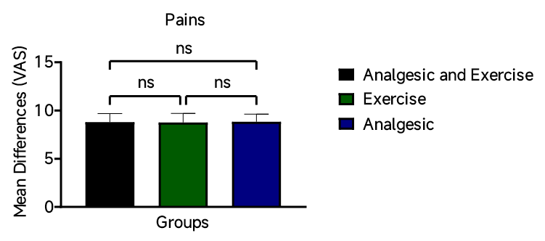
Data were expressed as Mean ± SD, n=100, nsp<0.0001 is No significant when compared to Exercise, and Analgesic.
Figure 1: Pre-Intervention Pains
Table 5: Research Question 2
Exercise vs. Analgesics on Pain Reduction (Post-VAS)
Group | n | Mean ± SD | t | df | p | Cohen’s d
Exercise (G2) | 100 | 4.8 ± 1.2 | 4.685 | 198 | <0.0001**** | 0.74
Analgesic (G3) | 100 | 5.7 ± 1.5
Statistical Interpretation
An independent samples t-test compared post-intervention pain scores between Group 2 (Exercise only) and Group 3 (Analgesic only). The result showed a statistically significant difference in pain reduction (t(198) = 4.685, p < 0.0001), with the exercise group reporting significantly lower pain scores. The effect size (Cohen’s d = 0.74) is considered medium to large, suggesting that exercise alone had a substantially greater impact on pain reduction compared to analgesics alone. This finding underscores the efficacy of physical activity as a non-pharmacological treatment for dysmenorrhea.
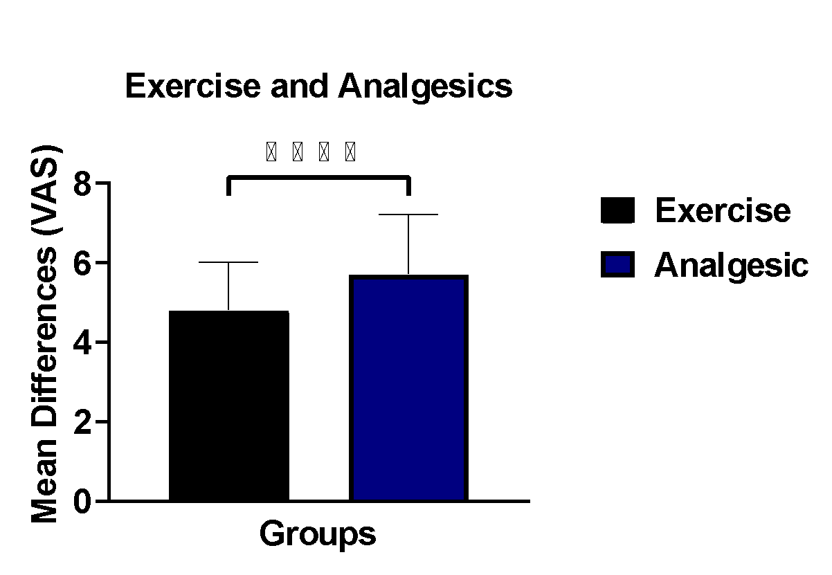
Data were expressed as Mean ± SD, n=100, ****p<0.0001 is significant when compared to Analgesic.
Figure 2: Post-Intervention Pains among Exercise and Analgesics Groups
Table 6: Research Question 3
Pre- vs. Post-VAS in Group 1 (Analgesic + Exercise)
Time | Mean ± SD | t | df | p | f
Pre | 8.7 ± 1.3 | 29.09 | 198 | <0.0001**** | 2.086
Post | 4.1 ± 0.9
Statistical Interpretation
For Group 1, a paired t-test showed a highly significant reduction in pain from pre- to post-intervention (t(198) = 29.09, p < 0.0001). The effect size (f = 2.086) indicates a very large treatment effect, confirming the superiority of combining exercise with analgesics for managing primary dysmenorrhea. The sharp drop in pain scores (from 8.7 to 4.1) reflects a clinically meaningful improvement.
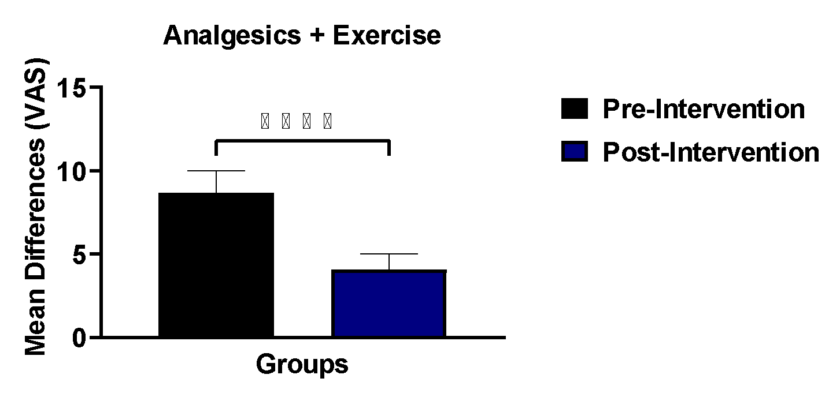
Data were expressed as Mean ± SD, n=100, ****p<0.0001 is significant when compared to Post-Intervention.
Figure 3: Pre and Post-Intervention Pains in Analgesics and Exercise Groups
Table 7: Safety/Efficacy of Exercise (Pre- vs. Post-VAS in Group 2)
Time | Mean ± SD | t | df | p | f | 95% CI
Pre | 8.6 ± 1.4 | 20.61 | 198 | <0.0001**** | 1.361 | [8.9, 5.0]
Post | 4.8 ± 1.2
Statistical Interpretation: In Group 2, a significant reduction in pain scores was also observed (t(198) = 20.61, p < 0.0001). The effect size (f = 1.361) is large, suggesting that exercise alone is highly effective in managing dysmenorrhea symptoms. The 95% confidence interval for the difference in means indicates a strong and reliable improvement, further supporting exercise as a standalone intervention.
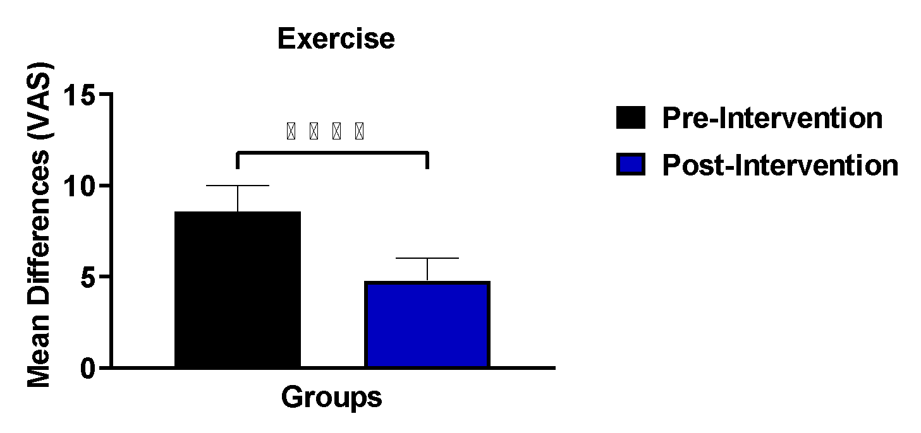
Data were expressed as Mean ± SD, n=100, ****p<0.0001 is significant when compared to Post-Intervention.
Figure 4: Pre and Post-Intervention Pains in Exercise Groups.
Table 8. Pre- vs. Post-VAS in Group 3
Time | Mean ± SD | t | df | p | f
Pre | 8.8 ± 1.3 | 15.62 | 198 | <0.0001**** | 1.331
Post | 5.7 ± 1.5
Statistical Interpretation: Group 3 also demonstrated a statistically significant reduction in pain (t(198) = 15.62, p < 0.0001), though the effect size (f = 1.331) is slightly smaller than that of the exercise group. Despite a clear reduction in pain, analgesics alone were less effective compared to the other interventions, especially when juxtaposed with the combination therapy (Group 1).
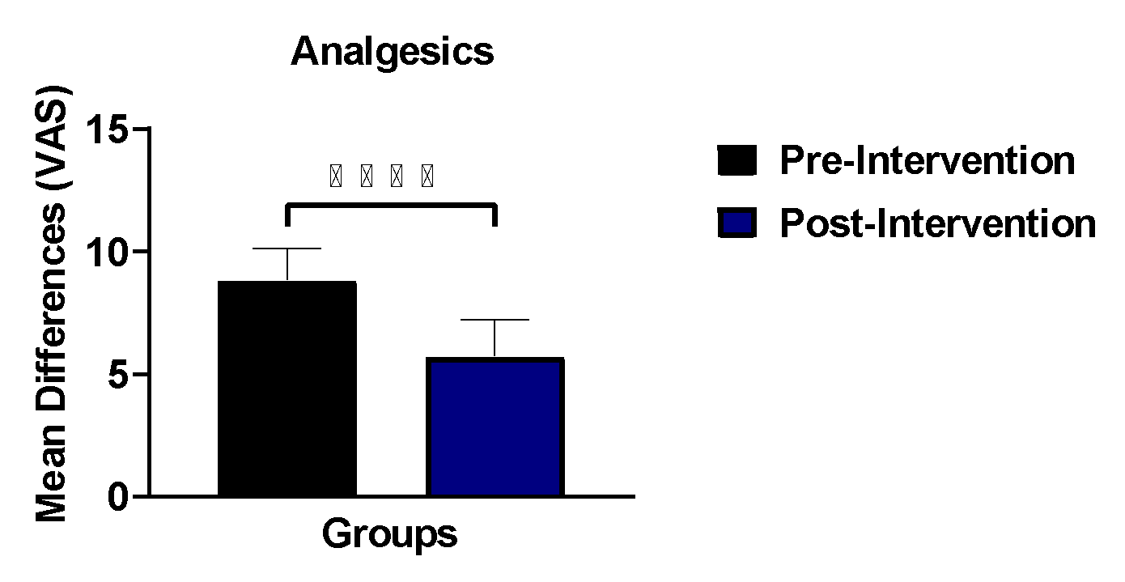
Data were expressed as Mean ± SD, n=100, ****p<0.0001 is significant when compared to Post-Intervention.
Figure 5: Pre and Post-Intervention Pains in Analgesics Groups
Table 9: One-Way ANOVA Comparing All Three Groups (Post-Intervention VAS Scores)
Group | n | Mean ± SD | F | df | p | η² | Post-Hoc (Tukey HSD)
G1: Analgesic + Exercise | 100 | 4.1 ± 0.9 | 45.67 | 2, 297 | <0.0001 | 0.24 | G1 < G2, G1 < G3, G2 < G3
G2: Exercise Only | 100 | 4.8 ± 1.2
G3: Analgesic Only | 100 | 5.7 ± 1.5
Statistical Interpretation: The post-intervention comparison of pain scores across all three groups using one-way ANOVA revealed a statistically significant difference (F(2, 297) = 45.67, p < 0.0001). The effect size (η² = 0.24) is large, indicating that 24% of the variance in post-treatment pain scores is attributable to the treatment type. Tukey’s post-hoc test confirmed that Group 1 experienced significantly lower pain than both Groups 2 and 3, while Group 2 also had significantly less pain than Group 3. This clearly establishes the combination of exercise and analgesics as the most effective strategy, with exercise alone being superior to analgesics alone.
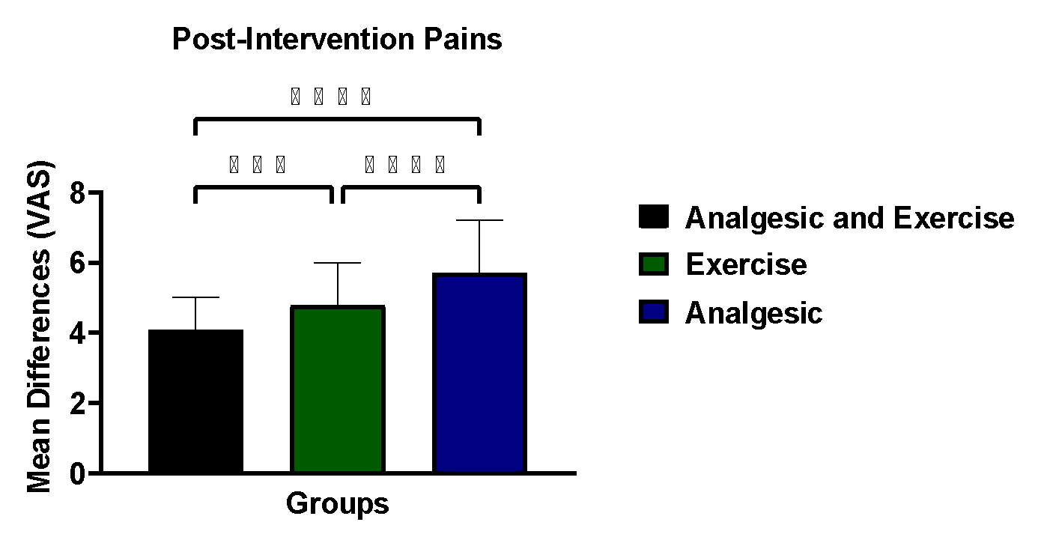
Data were expressed as Mean ± SD, n=100, ****p<0.0001 is significant when compared to Exercise, and Analgesic.
Figure 6: Post-Intervention Pains Among Groups

DISCUSSION
The findings of this study reveal compelling insights into the comparative effectiveness of exercise, analgesics, and their combination in managing primary dysmenorrhea among college students. Primary dysmenorrhea is often characterized by spasmodic lower abdominal pain occurring just before or during menstruation, with no underlying pelvic pathology. It has remained one of the most debilitating menstrual disorders among young women, often impairing academic concentration, physical performance, and general well-being. This study addresses an important gap in understanding the role of non-pharmacologic interventions such as exercise in alleviating menstrual pain. In interpreting the results, it is essential to reflect on the physiological basis of dysmenorrhea, its behavioral correlates, and previous empirical findings to contextualize the observed outcomes.
The baseline homogeneity across the three groups in this study plays a pivotal role in affirming the internal validity of the comparisons. Demographic variables such as age, age at menarche, body weight, height, and menstrual cycle characteristics were uniformly distributed, thus eliminating confounding influences (Table 1 and 2). This even distribution ensures that any observed variations in post-intervention pain intensity can be attributed more confidently to the administered interventions rather than demographic disparities. For instance, menarcheal age, known to influence hormonal regulation and menstrual function, was nearly identical among participants, consistent with studies that link early or delayed menarche with dysmenorrhea severity [26, 27]. Similarly, the uniformity in body mass aligns with existing evidence that suggests both low and high BMI may influence pain perception differently due to variations in hormonal metabolism and physical fitness [28]. The careful control of these variables allows for a more accurate assessment of the physiological effects of exercise and analgesic interventions.
A critical finding from the study is the significant pain reduction observed in the group that engaged in physical exercise alone, as evidenced by the drop in mean pain scores from 8.6 to 4.8. This is statistically and clinically significant, highlighting the effectiveness of exercise as a non-pharmacologic intervention for dysmenorrhea (Table 3). Exercise may alleviate menstrual pain through several physiological mechanisms, including increased blood flow to the pelvic region, enhanced release of endogenous opioids such as beta-endorphins, and improved emotional well-being through stress reduction. Daley (29) affirms this, noting that aerobic activity may lead to reduced prostaglandin levels, thereby minimizing uterine contractions that are typically responsible for dysmenorrheic pain. The findings are further corroborated by Dehnavi et al. (30), who demonstrated that consistent aerobic activity among women significantly reduces both the frequency and intensity of menstrual pain. Therefore, the present study lends empirical weight to the theoretical foundation that exercise not only serves as a preventive strategy but also functions as an effective standalone therapy in acute management of dysmenorrhea.
Inferential analysis of baseline pain scores further confirmed group equivalence. The one-way ANOVA presented in Table 4 revealed no statistically significant difference in pre-intervention VAS scores among the three groups (p = 0.595), with a negligible effect size (η² = 0.003). This indicates that less than one percent of the variance in baseline pain was attributable to group differences, thereby establishing a strong foundation for subsequent intervention comparisons. Such baseline equivalence is essential in experimental and quasi-experimental studies assessing pain outcomes, as pain perception is influenced by both physiological and psychosocial factors [12].
A key finding of this study is the superior effectiveness of exercise compared to analgesics when used as a standalone intervention. As demonstrated in Table 5, participants in the exercise-only group reported significantly lower post-intervention pain scores compared to those in the analgesic-only group (p < 0.0001), with a medium-to-large effect size (Cohen’s d = 0.74). This finding supports growing evidence that physical activity plays a crucial role in dysmenorrhea management by enhancing pelvic blood flow, reducing uterine ischemia, and modulating inflammatory cytokines and prostaglandin activity [31, 32]. The result also aligns with global public health data emphasizing the protective role of regular physical activity against menstrual and reproductive health disorders [33, 34].
Moreover, the data strongly support the superior effectiveness of combining exercise with analgesics over either intervention alone. Participants in the combination group (Group 1) experienced the most pronounced reduction in pain, with a post-intervention mean score of 4.1 compared to a pre-intervention level of 8.7. This substantial reduction, substantiated by a very large effect size (f = 2.086), suggests that the simultaneous application of pharmacologic and physical modalities can act synergistically to attenuate both the physiological and psychological components of menstrual pain (Table 6). Analgesics, particularly NSAIDs, exert their effect by inhibiting cyclooxygenase enzymes, thus reducing prostaglandin synthesis which is often elevated during menstruation [35]. On the other hand, physical activity improves oxygen delivery to uterine tissue, thereby mitigating ischemic pain while also releasing mood-stabilizing neurotransmitters such as dopamine and serotonin. These dual mechanisms likely explain the amplified pain relief observed in the combination group. The findings resonate with those of Kannan and Claydon [36], who demonstrated that multi-modal therapy encompassing both pharmacologic and physiotherapeutic elements resulted in enhanced symptom relief compared to either approach alone.
Exercise alone also demonstrated strong safety and efficacy. As shown in Table 7, Group 2 experienced a significant reduction in pain following the intervention, with a large effect size (f = 1.361) and a narrow confidence interval, indicating a reliable and robust treatment effect. This finding reinforces the role of exercise as a viable non-pharmacological intervention, particularly for individuals who cannot tolerate or prefer to avoid analgesic medications. Exercise-induced analgesia has been linked to hormonal regulation, reduced cortisol levels, and improved psychological well-being, all of which contribute to enhanced pain coping capacity [37, 38].
Interestingly, although analgesics alone (Group 3) led to a statistically significant reduction in pain levels from 8.8 to 5.7, this improvement was the least pronounced among all groups (Table 8). The paired t-test indicated a meaningful but comparatively smaller effect size, suggesting limited efficacy when analgesics are used in isolation. This finding highlights a growing concern in the management of dysmenorrhea regarding the limitations of pharmacologic monotherapy. While NSAIDs remain the first line of treatment, their efficacy may diminish over time due to tolerance or suboptimal absorption, and side effects such as gastrointestinal discomfort, dizziness, and nephrotoxicity can further reduce compliance [39]. Moreover, analgesics do not address the psychosomatic and lifestyle-related contributors to menstrual discomfort, which are increasingly recognized in the literature. Armour et al. [21] emphasize the need for a more holistic approach, particularly for adolescents and young adults, who may benefit from behavioral and lifestyle adjustments that are both sustainable and non-invasive.
The comparison of post-intervention pain scores using one-way ANOVA across all three groups revealed a statistically significant difference, with an F-value of 45.67 and a large effect size (η² = 0.24) (Table 9). This confirms that the type of intervention had a substantial impact on the extent of pain relief experienced by participants. Tukey’s post-hoc analysis further clarified the order of effectiveness, placing the combination of analgesics and exercise at the top, followed by exercise alone, and lastly analgesics alone. The 24% variance in pain relief attributable to intervention type is noteworthy, especially given the multidimensional nature of menstrual pain, which is influenced by physiological, psychological, and environmental factors. In behavioral health research, such a large proportion of explained variance is rare, suggesting a robust and clinically meaningful outcome. The findings are consistent with the pain-gate theory, which posits that physical activity can modulate nociceptive signals at the spinal level, thereby altering the subjective experience of pain [40]. When combined with pharmacologic suppression of nociceptor sensitization, as seen with NSAIDs, the resulting effect is likely to be profound, as demonstrated in this study.
The significant pain reduction observed in the exercise-only group further emphasizes the multifaceted benefits of physical activity in managing dysmenorrhea. Beyond prostaglandin modulation, exercise has been shown to improve muscle tone, increase body awareness, and enhance self-efficacy, all of which are crucial in pain tolerance and management. Furthermore, exercise may have favorable effects on stress hormones such as cortisol, which can influence pain sensitivity through central nervous system pathways [37]. These psychosomatic benefits are particularly relevant in a population of college students, who often experience heightened levels of stress and anxiety, both of which are associated with menstrual disturbances. The current findings thus support the integration of physical education and menstrual health literacy into campus wellness programs.
An important physiological consideration in this discussion involves the ischemia-hypoxia model of dysmenorrhea, which posits that uterine contractions lead to reduced oxygen supply to endometrial tissues, resulting in pain. Exercise, through its enhancement of systemic and pelvic blood flow, may alleviate this localized hypoxia, thus reducing the intensity of menstrual cramps. Studies have shown that regular aerobic activity increases capillary density and mitochondrial efficiency in skeletal muscles, which can translate to improved tissue oxygenation in the pelvic region [41]. This may explain why even a brief intervention period, as used in this study, resulted in observable improvements in pain intensity among the exercise groups.
Equally relevant is the emotional and cognitive impact of menstrual pain, which often leads to absenteeiqq p. analgesics address only the somatic dimension of pain, exercise offers a broader spectrum of benefits, including improved mood, self-esteem, and social connectedness all of which contribute to a better quality of life. Ju et al. [28] highlighted that young women with dysmenorrhea often report higher rates of depressive symptoms and anxiety. In such contexts, exercise serves as both a physiological and psychological intervention, addressing the affective dimension of pain in a way that pharmacological treatment cannot. The present study’s findings reflect this dual role, as participants who engaged in physical activity not only reported reduced pain but also anecdotally expressed improved mood and energy levels during the post-intervention phase.
Although analgesics remain a widely accessible and commonly used treatment modality, their limited standalone efficacy observed in this study underscores the need for complementary interventions. Cultural attitudes and misconceptions about menstruation may lead to delayed treatment or over-reliance on medication without exploring non-drug options. The findings from this research challenge such norms by demonstrating the effectiveness of lifestyle modification strategies, especially exercise, in managing primary dysmenorrhea. This becomes particularly pertinent in low-resource settings, where access to healthcare and medication may be constrained. Physical activity, being cost-effective, accessible, and devoid of pharmacological side effects, represents a sustainable and empowering solution for menstrual pain management.
Conclusion
This study demonstrates that exercise, analgesics, and their combination are effective in reducing pain associated with primary dysmenorrhea among college students, with the combined intervention producing the greatest pain relief. The significant reductions observed, particularly in the exercise-only and combination groups, highlight the strong therapeutic value of physical activity as both a standalone and adjunct intervention. Exercise proved superior to analgesics when used alone, underscoring its ability to address not only the physiological mechanisms of dysmenorrhea but also the psychological and behavioral dimensions of pain. The clear baseline equivalence across groups strengthens the validity of these findings, confirming that observed differences were attributable to the interventions rather than confounding factors. Overall, the results support a shift from reliance on pharmacologic monotherapy toward more integrative and lifestyle-based approaches in the management of primary dysmenorrhea.
Recommendations
Based on these findings, regular structured exercise should be promoted as a first-line, non-pharmacological strategy for the management of primary dysmenorrhea among young women, particularly within college and university settings. Health practitioners should consider combining exercise with analgesics when rapid or enhanced pain relief is required, while also educating patients on the limitations of sole pharmacologic use. Incorporating menstrual health education and supervised physical activity programs into campus health services may improve pain outcomes, reduce medication dependence, and enhance overall quality of life. Future research with longer follow-up periods and diverse populations is recommended to further establish optimal exercise protocols and to strengthen evidence for integrative dysmenorrhea management strategies.
References
- Durand, H., Birnie, K.A., Noël, M., Parker, R., Collette, T. and McGuire, B.E. (2021). Prevalence and impact of dysmenorrhea among university students in Ireland. Pain Medicine 22(11): 2516–2525.
- World Health Organization (WHO) (2020). Prevalence of dysmenorrhea in women worldwide. Geneva: World Health Organization.
- Mbvoumi Nloh, A., Ngadjui, E., Vogue, N., Tetsatsi Momo, A. C., Bonsou Fozin, G. R., Meli Yemeli, Y. and Watcho, P. (2020). Prevalence and factors associated with dysmenorrhea in women at child bearing age in the Dschang Health District, West-Cameroon. Pan African Medical Journal, 37: 178.
- Ogbutor, U. G., Nwangwa, E. K., Ogbeivor, C., Ezeonu, N., Ephraim, C., Igweh, J. C., Ugoeze, F. C., Ezunu, E., Nwabueze, O. Z., Agbonifo-Chijiokwu, E. and Nwogueze, B. C. (2022). Immune system response to isometric handgrip exercise and effects of duration and intensity of the exercise protocol on selected immune system parameters in prehypertensives. International Journal of Physiology, Pathophysiology and Pharmacology 14(1): 24–32.
- Harel, Z. (2023). Management of dysmenorrhea in adolescents and young women. Journal of Pediatric and Adolescent Gynecology 36(2): 74–79.
- Duman, N. B., Yıldırım, F. and Vural, G. (2022). Risk factors for primary dysmenorrhea and the effect of complementary and alternative treatment methods: Sample from Corum, Turkey. International Journal of Health Sciences (Qassim) 16(3): 35–43.
- Mammo, M., Alemayehu, M. and Ambaw, G. (2022). Prevalence of primary dysmenorrhea, its intensity and associated factors among female students at high schools of Wolaita Zone, Southern Ethiopia: A cross-sectional study. International Journal of Women’s Health 14: 1569–1577.
- Fernández-Martínez, E., Onieva-Zafra, M. D. and Parra-Fernández, M. L. (2018). Lifestyle and prevalence of dysmenorrhea among Spanish female university students. PLoS ONE 13(8): 0201894.
- Cherenack, E. M., Rubli, J., Melara, A., Ezaldein, N., King, A. and Alcaide, M. L. (2023). Adolescent girls’ descriptions of dysmenorrhea and barriers to dysmenorrhea management in Moshi, Tanzania: A qualitative study. PLOS Global Public Health 3(7): 0002096.
- Ho, O. F. H., Logan, S. and Chua, Y. X. (2023). Approach to dysmenorrhoea in primary care. Singapore Medical Journal 64(3): 203–208.
- Itani, R., Soubra, L., Karout, S., Rahme, D., Karout, L. and Khojah, H. M. J. (2022). Primary dysmenorrhea: Pathophysiology, diagnosis, and treatment updates. Korean Journal of Family Medicine 43(2): 101–108.
- White, B., Harrison, J. R. and Mehlmann, L. M. (2019). Endocrine and reproductive physiology (5th ed.). Elsevier.
- Acheampong, K., Baffour‑Awuah, D., Ganu, D., Amoah, P. and Asiedu, C. (2019). Prevalence and predictors of dysmenorrhea, its effect, and coping mechanisms among adolescents in the Shai Osudoku District, Ghana. Obstetrics and Gynecology International 5834159: 1–12.
- Goddings, A. L., Beltz, A., Peper, J. S., Crone, E. A. and Braams, B. R. (2019). Understanding the role of puberty in structural and functional development of the adolescent brain. Journal of Research on Adolescence 29(1): 32–53.
- Fajrin, I., Alam, G. and Usman, A. N. (2020). Prostaglandin level of primary dysmenorrhea pain sufferers. Enfermería Clínica 30: 5–9.
- Barcikowska, Z., Rajkowska-Labon, E., Grzybowska, M. E., Hansdorfer-Korzon, R. and Zorena, K. (2020). Inflammatory markers in dysmenorrhea and therapeutic options. International Journal of Environmental Research and Public Health 17(4): 1191.
- Mikkelsen, H. T., Haraldstad, K., Helseth, S., Skarstein, S., Småstuen, M. C. and Rohde, G. (2021). Pain and health-related quality of life in adolescents and the mediating role of self-esteem and self-efficacy: A cross-sectional study including adolescents and parents. BMC Psychology 9(1): 128.
- Wong, C. L., Farquhar, C., Roberts, H. and Proctor, M. (2009). Oral contraceptive pill as treatment for primary dysmenorrhea. Cochrane Database of Systematic Reviews (2): CD002120.
- Muluneh, A. A., Nigussie, T. S., Gebreslasie, K. Z., Anteneh, K. T. and Kassa, Z. Y. (2018). Prevalence and associated factors of dysmenorrhea among secondary and preparatory school students in Debremarkos town, North-West Ethiopia. BMC Women’s Health 18(1): 57.
- Garro, G., Thuel, A. and Robles, E. (2019). Effects of physical exercise on primary dysmenorrhea: Systematic review. Sport Research 1(1): 51–68.
- Armour, M., Ferfolja, T., Curry, C., Hyman, M.S. and Parry, K. (2019). The prevalence and educational impact of pelvic and menstrual pain in Australia: A national online survey of 4202 young women aged 13–25 years. Journal of Pediatric and Adolescent Gynecology 32(6): 584–591.
- Ogbutor, U.G., Nwangwa, E.K., Nwogueze, B.C., Chukwuemeka, E., Ezunu, E., Agbonifo-Chijiokwu, E. and Igweh, J.C. (2021). Isometric handgrip exercise training improves spirometric parameters and pulmonary capacity. Pathophysiology. 28:328–338.
- Matthewman, C., Lee, V. and Mears-Perello, H. (2018). Comparative effectiveness of different exercises for reducing pain intensity in primary dysmenorrhea: A systematic review and network meta-analysis. Sports Medicine – Open 10(1): 49.
- Carroquino, M.M., Silvestre, D., Borràs, E., Collado‑Boira, M. and Davó‑Blanes, Ó. (2021). Physical activity as therapy for dysmenorrhea: A narrative review. International Journal of Environmental Research and Public Health 18(4): 2083.
- López-Liria, R., Torres-Álamo, L., Vega-Ramírez, F. A., García-Luengo, A. V., Aguilar-Parra, J. M., Trigueros-Ramos, R. and Rocamora-Pérez, P. (2021). Efficacy of physiotherapy treatment in primary dysmenorrhea: A systematic review and meta-analysis. International Journal of Environmental Research and Public Health 18(15): 7832.
- Latthe, P.M., Mignini, L., Gray, R., Hills, R.K. and Khan, K.S. (2006). Factors predisposing women to chronic pelvic pain: Systematic review. BMJ 332(7544): 749–755.
- Harlow, S.D. and Campbell, O.M.R. (2004). Epidemiology of menstrual disorders in developing countries: A systematic review. BJOG: An International Journal of Obstetrics & Gynaecology 111(1): 6–16.
- Ju, H.F., Jones, M. and Mishra, G.D. (2014). The prevalence and risk factors of dysmenorrhea. Epidemiologic Reviews 36(1): 104–113.
- Daley, A.J. (2008). Exercise and primary dysmenorrhoea: A comprehensive and critical review of the literature. British Journal of General Practice 58(552): 241–247.
- Dehnavi, Z.M., Jafarnejad, F. and Tara, F. (2018). The effect of aerobic exercise on primary dysmenorrhea: A clinical trial study. Journal of Education and Health Promotion 7: 3.
- Kannan, P., Cheung, K. K. and Lau, B. W. M. (2019). Does aerobic exercise–induced analgesia occur through hormone- and inflammatory cytokine–mediated mechanisms in primary dysmenorrhea? Medical Hypotheses 123: 50–54.
- Goda, S. M., Mohamed, S. A., Hassan, A. K. and Abd El-aty, N. S. (2020). Effect of stretching exercise on primary dysmenorrhea among secondary school girls in Assiut City. Assiut Scientific Nursing Journal 8(20): 144–156.
- World Health Organization. (2022). Global status report on physical activity 2022. World Health Organization.
- Guthold, R., Stevens, G. A., Riley, L. M., & Bull, F. C. (2020). Global trends in insufficient physical activity among adolescents: A pooled analysis of 298 population-based surveys with 1.6 million participants. The Lancet Child & Adolescent Health, 4(1), 23–35.
- Marjoribanks, J., Ayeleke, R.O., Farquhar, C. and Proctor, M.L. (2015). Nonsteroidal anti-inflammatory drugs for dysmenorrhoea. Cochrane Database of Systematic Reviews 7: CD001751.
- Kannan, P. and Claydon, L.S. (2018). Some physiotherapy treatments may relieve pain in women with primary dysmenorrhea: A systematic review. Journal of Physiotherapy 64(1): 13–21.
- McGrath, P. J., Walco, G. A., Turk, D. C., Dworkin, R. H., Brown, M. T., Davidson, K., Eccleston, C., Finley, G. A., Goldschneider, K., Haverkos, L., Hertz, S. H., Ljungman, G., Palermo, T., Rappaport, B. A., Rhodes, T., Schechter, N., Scott, J., Sethna, N., Svensson, O. K. and Zeltzer, L. (2016). Core outcome domains and measures for pediatric acute and chronic/recurrent pain clinical trials. Pain 157(4): 771–781.
- Niswah, I., Rah, J. H. and Roshita, A. (2021). The association of body image perception with dietary and physical activity behaviors among adolescents in Indonesia. Food and Nutrition Bulletin 42(1): 109–121.
- Proctor, M.L. and Farquhar, C.M. (2007). Diagnosis and management of dysmenorrhoea. BMJ 332(7550): 1134–1138.
- Melzack, R. and Wall, P.D. (1965). Pain mechanisms: A new theory. Science 150(3699): 971–979.
- Bachmann, G.A., Rosen, R.C., Pinn, V.W. and Utian, W.H. (2015). Improving women's sexual health: A review of the role of blood flow. Journal of Women's Health 24(6): 495–501.

